PUBLIC ART COMMISSION

Richmond, Virginia

REQUEST FOR QUALIFICATIONS

Southside Community Center Stormwater Garden Art Project
Richmond Public Art Commission, Virginia

Introduction
Richmond’s Public Art Commission is seeking a permanent public art installation at the Southside Community Center currently undergoing significant expansion. The new facility, located at 6255 Old Warwick Road North, Chesterfield, VA, will provide interactive, lively spaces for community wellness and recreation activities. The grounds surrounding the Community Center include multiple sports fields, a skate park, playground, community garden, and other community spaces. The grounds also include one bioretention area and two stormwater detention areas that provide an excellent opportunity for an artist or design team to create a unique installation that actively celebrates responsible stormwater practices. Three to five artists/teams will receive an honorarium of $2,000 each to submit a formal proposal for the project.

RFQ Deadline: December 19, 2022

Honorarium for Draft Proposal: $2,000

Commission Budget: $200,000 (inclusive of all artist’s fees, materials, insurance, fabrication,
installation, travel and all other project-related expenses)

Eligibility
This project is open to artists and design teams—broadly defined as artists, sculptors, landscape designers, architects, et al.—living within the United States and its territories working in any medium appropriate for the site.

Background
The City of Richmond Department of Parks, Recreation and Community Facilities purchased the Southside Community Center property in 2014 with the goal of creating a regional park to provide diversified recreational opportunities for the residents of the Midlothian Planning District. The current site master plan—developed by Worley Associates and Timmons Group—was approved by the City’s Urban Design Committee and Planning Commission in 2018. The site master plan consists of a new community center building and exterior park features that include an entry plaza and drop-off, playground, community garden, orchard, basketball court, softball field, trails, a multi-purpose field and a skatepark.

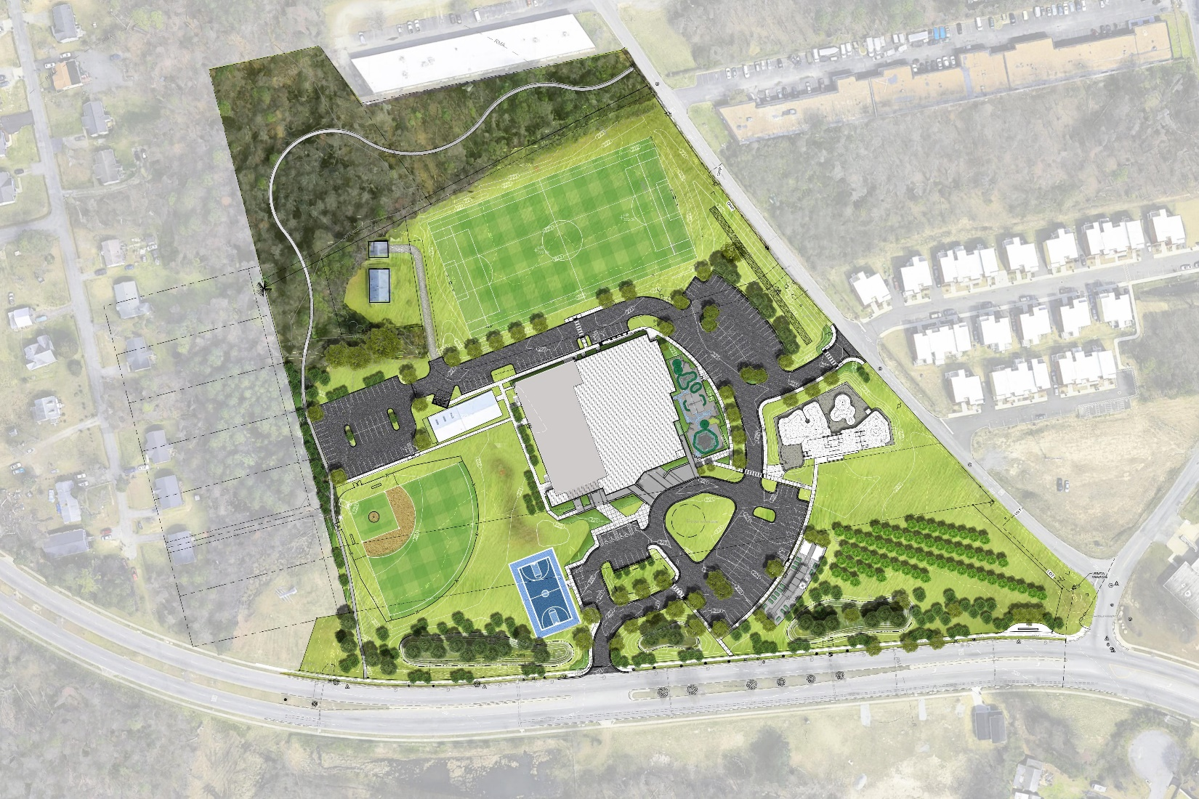
Old Carnation Street

The park’s bioretention and stormwater detention ponds are located along and visible from Old Carnation Street (indicated by the three arrows in the site plan), which is also the main entrance to the Community Center.

Project Intent
The vision for this project is an interactive art installation along Old Carnation Street that celebrates responsible stormwater management and adds inviting and surprising character to the Southside Community Center’s park.

Goals
- Provide a creative intervention that celebrates and enhances the property’s planned rainwater management system and bioretention or stormwater detention ponds
- Include an educative moment by creating an installation that demonstrates and/or visualizes the water cycle or related topic (benefits of open/landscaped stormwater systems versus closed/engineered systems, native plant and wildlife habitat, water conservation and re-use, etc.)
- Enhance the main entrance to the Center
- Reinforce the communal nature of the Center and safely accommodates visitors of all ages
- Actively engage the community in the pre-planning, design and/or installation of the work
- Ensure durability and easy maintenance

Artist Selection Criteria
Three to five artists will be selected to submit a formal proposal based on their qualifications. The RFQ must demonstrate the following qualifications:

Preliminary Evaluation Criteria
Artistic excellence
Originality of preliminary concept
Compatibility of concept to project goals
Community engagement experience/plans
Experience completing public art projects of this scale

The PAC is committed to reflecting the diversity and cultural richness of Richmond, VA in our selection process.

Artist Selection Process
All RFQs will be reviewed by the Artist Selection Panel consisting of a Public Art Commissioner, one representative from the project design firm, several artists (may include sculptors, landscape designers and/or architects), a representative from the Richmond Department of Parks Recreation and Community Facilities, a City Council Liaison and a representative of the neighborhood.

Three to five finalists will be invited to submit a full proposal to the Artist Selection Panel; round 2 evaluation criteria will be provided to each finalist.

Finalists may be asked to make a presentation of their proposal to the Artist Selection Panel.

The Artist Selection Panel will review proposals and make its recommendations to the full Public Art Commission.

The Public Art Commission will make its final recommendation.

The Public Art Commission will present its final recommendation to the City Planning Commission.

The City Planning Commission will approval a final proposal.

How to Apply
Artists interested in this project should submit an application at: https://rvapac.slideroom.com/#/permalink/program/69997

Richmond, VA’s Public Art Program
The mission of Richmond’s Public Art Program is to equitably invest in artists as essential partners contributing to the City’s economic, infrastructure, environmental, and cultural identity and growth. The Public Art Program envisions a City where citizens and visitors value the arts as a vital public asset, where developers routinely contribute to public art as a dynamic tool for enlivening community gathering places, and where artists reify Richmond’s many histories, celebrate Richmond’s present, and help shape Richmond’s future.

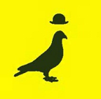
RICHMOND, VA
PUBLIC ART COMMISSION
EQUITY STATEMENT

Cultural Equity embodies the values, beliefs, policies, and practices that ensure all people can exercise their right of cultural expression and economic livelihood within the arts ecosystem. This guiding principle requires a commitment to citizens who have historically been underrepresented in mainstream arts programming, discourse, leadership, and resource allocation.
The Public Art Commission of Richmond, Virginia acknowledges these longstanding inequities, recognizes that differences are not deficiencies and strives to counter this in our work. We hold ourselves accountable for enacting policies and operating procedures that value and celebrate everyone’s life experiences and their histories. We are committed to the full scope of this work to ensure that individuals from under-invested and under-represented communities can compete equitably for artist commissions, are actively sought for open positions on the Commission, and are included on curatorial review panels and site selection committees.
By consistently bringing new perspectives to our decision-making, forming new relationships and alliances, and finding new ways to support creativity, the Public Art Commission aspires to be an essential voice in making Richmond a diverse, equitable, and inclusive community.

