Bruce’s Beach Request for Proposals

Project Overview:
The City of Manhattan Beach is seeking to commission an original, site-specific sculptural artwork to honor the history and legacy of the Bruce’s Beach neighborhood. The artwork should evoke a sense of peace, healing, and community, and offer an educational opportunity for visitors to learn about the history of this area.
The racial reckoning of 2020 has provided the City of Manhattan Beach with specific opportunities to remember and confront the past and tackle the difficult but necessary steps forward. The history of Bruce’s Beach provides a focus and space for this renewed work. Additional information regarding the history of this site can be found below and in the History Report linked in the Additional Resources section.
Aerial view of Manhattan Beach Pier facing east

Budget:
Not to exceed $350,000 all inclusive

Submissions:
Submissions will be received from March 1, 2023 to March 31, 2023 at 5:00 PM.
All submissions must be received electronically via email.
Late, incomplete, ineligible, or non-electronic submissions will not be considered.

Project and Site Description:
Bruce’s Beach Park is nestled in a quiet suburban area, where residents and visitors alike enjoy beachfront views and a restful atmosphere. It is located on a steep hill, several blocks from the beach and is terraced into five sections with trees, shrubs, seating, and recreation areas.
The upper terrace hosts a newly installed plaque, commemorating the events that led to the creation of this park. In recent years, this plaque has become a place of gathering and pilgrimage, where families lay flowers, photos, and mementos in solidarity with the history of Black Americans in the area.
While this small park does not lend itself to large gatherings or events, it is heavily used for field games and dog walking (mainly on the lowermost terrace), basketball games and other activities on the middle concrete terrace (Bayview Drive), and recreationally to walk, rest, exercise, and view the ocean.
The proposed artwork must take into account the size, location, topography, and current use of the park. The artwork may consist of one or multiple elements, may incorporate the new plaque and surrounding concrete pad*, and may be located anywhere in the park, so long as it meets all Americans with Disabilities Act (ADA) and other access requirements.** The artwork must present an educational and historical view of the events that led to this day and have strong Diversity, Equity, and Inclusion ties.
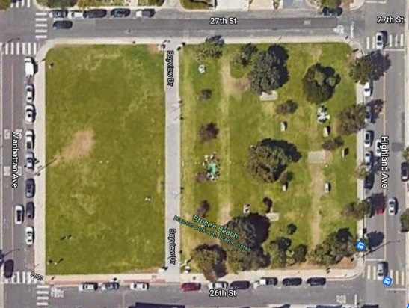
Aerial view of Bruce’s Beach Park

Notes:
*While the proposal may incorporate the new concrete pad and plaque, no new structures may be placed onto the concrete space. In some cases, it may be possible to alter the concrete visually by coloring or texturing it. At no point shall the proposed treatment interfere with the safety and ADA compliance of the space, including creating an unsafe surface (slick/slippery surface or textures that may result in a tripping hazard). Artwork and components may be proposed next to or abutting the concrete pad and additional concrete substrate may be proposed to support these or other elements, provided that they are within the overall budget of the project and are engineered/constructed in a safe manner appropriate to the site.
**The American with Disabilities Act (ADA) requires that any person is able to access and enjoy a public facility (including Public Art) in an equal manner. For the purpose of this RFP, an eligible artwork must either be able to be equally enjoyed from any location or distance, or have a clear, ADA compliant path to and around it. This applies particularly to any areas of seating, text (including didactic panels, quotes, words, plaques, QR codes or any other information requiring the ability to read), interactive elements (viewing platforms, play/game elements, photo spots etc.) or other components created for direct interaction with the artwork. For artworks requiring an ADA path, the most easily accessible area is on the upper terrace adjacent to Highland Avenue. Even on this terrace, however, regrading, resurfacing, and landscaping changes may be necessary to comply with the standards. For more details regarding ADA regulations, please consult 2022 California Building code at: CHAPTER 11B ACCESSIBILITY TO PUBLIC BUILDINGS, PUBLIC ACCOMMODATIONS, COMMERCIAL BUILDINGS AND PUBLIC HOUSING, 2022 California Building Code, Title 24, Part 2 (Volumes 1 & 2) | ICC Digital Codes (iccsafe.org).
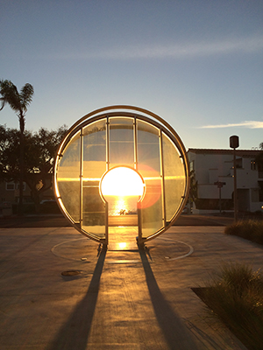
Artwork Goals:
The City of Manhattan Beach strives to create and commission artworks that reflect aesthetic and technical quality and foster a welcoming, uplifting environment for growth. This artwork must focus on the history and education surrounding Bruce’s Beach and promote reflection, introspection, and healing. Artwork should be inviting and conceptually accessible to viewers of all ages and backgrounds. Figurative entries are encouraged; however, non-literal interpretations are welcome to apply, provided that the message is clear. Successful artwork should not unduly disturb the serene view of the ocean, disrupt or prevent park activities, nor significantly alter existing landscaping.
The selected artist will collaborate with the City to refine and adjust the final proposal to meet City needs and expectations including but not limited to: aesthetic choices and considerations, thematic narrative, materials, size, location, and other aspects of the artwork.
Light Gate, installed by the City of Manhattan Beach in 2014. This interactive artwork provides a view of the setting sun directly through the center of the keyhole twice a year.

Eligibility:
This project is open to all professional artists and artist teams (here referred to collectively as “artist”) with public art experience, ages 21 and older, who demonstrate the ability to complete a project of this magnitude. Eligible applicants must have successfully completed a commissioned large scale public or private art project of similar scope. Artists must demonstrate strong understanding of and passion for Bruce’s Beach history. Artists from diverse backgrounds are encouraged to apply.
The artwork and all major components must be manufactured in the United States.
City staff, elected or appointed City officials, and immediate members of their families are not eligible for this project.

Artwork Materials and Maintenance:
This artwork must be ADA accessible, consider public safety, and be easy to clean and maintain. It should be durable, sturdy, stable, resistant to UV damage, and well suited for marine climate conditions.
The artwork must be consistent with the goals and description set forth in this RFP.
It must be made of sturdy industrial materials and able to withstand daily interaction with the public over a period of multiple decades with minimal maintenance.
The artwork need not incorporate: water or fountain elements, moving parts, mechanical elements needing power or electricity, lighting/illumination, solar or battery operated components, or materials that are easy to damage and/or difficult to clean and repair.
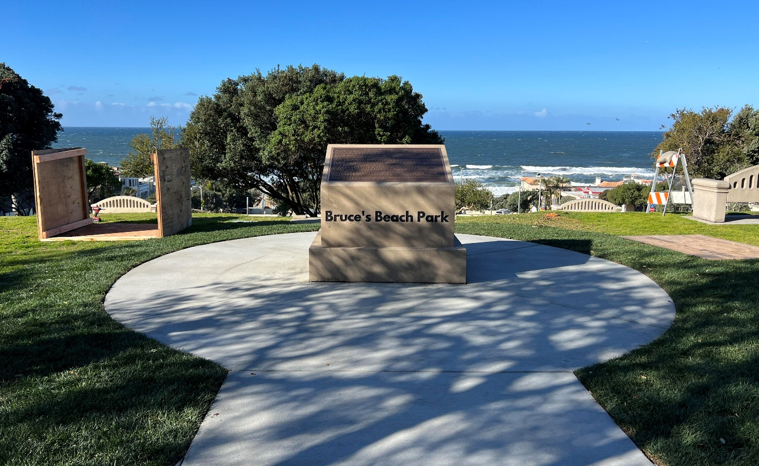
The submission must include a maintenance plan for the artwork including the cost of repairing or replacing damaged parts of the artwork.
Rendering of new plaque location and surrounding concrete pad
Concrete plaza measures 17’ in diameter and is set 6’ from the pedestrian sidewalk
History:
The City of Manhattan Beach created the Bruce’s Beach Task Force to further research and properly acknowledge the City’s racially motivated eminent domain action to dispossess Willa and Charles A. Bruce, Major George and Mrs. Ethel Prioleau, Elizabeth Patterson, Mary R. Sanders, Milton and Anna Johnson, as well as white property owners, of their property in the 1920s. The Task Force and the History Advisory Board (a subcommittee of the Task Force) drafted a History Report (see Additional Resources below) and subsequently the City Council adopted plaque language to be installed at Bruce’s Beach Park.
The following statement is taken directly from the language of the newly installed plaque at the top terrace in Bruce’s Beach Park. For more information about Bruce’s Beach and its history, please see Additional Resources below.
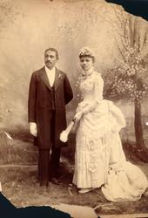
“Willa and Charles Bruce acquired property along the Strand in Manhattan Beach to create a beach resort for the Black community on February 19, 1912. By 1916, the resort known as “Bruce’s Beach” was a thriving fixture for the Black community, with a restaurant, dancehall, changing rooms, and showers. Soon after, several other Black families purchased property near the current park location. Major George Prioleau and Mrs. Ethel Prioleau, Elizabeth Patterson, Mary Sanders, Milton and Anna Johnson, John McCaskill and Elzia Irvin, and James and Lula Slaughter built homes on their property.
Unfortunately, not everyone in Manhattan Beach welcomed the Bruces’ enterprise and its crowds of Black patrons in that era of Jim Crow and racial segregation. The Bruces, their patrons, and the other Black property owners faced harassment, intimidation, and discrimination by some, including City Hall. These actions aimed to make Manhattan Beach inhospitable to Black residents and visitors. Enough White residents ultimately pressured the City Council to exercise its power of eminent domain to acquire the land for use as a public park. As a result, the City condemned the properties of the Bruces, the Prioleaus, the Johnsons, Ms. Patterson, and Ms. Sanders. In addition, twenty-five white-owned properties that sat undeveloped among the Black-owned properties were also condemned. The City’s action at the time was racially motivated and wrong.”
Charles and Willa Bruce, Circa 1886
Budget Description:
The $350K budget is all inclusive (with the exception of the stipends and travel reimbursement awarded to the five semi-finalists) and must include all costs associated with this project, including but not limited to:
- Research | - Professional consultation | - Site preparation
- Materials | - Fabrication | - Installation
- Contingency | - Equipment rental/use | - Transportation
- Travel/lodging | - Per diem | - Geological site study
- Packing/crating | - Delivery/transport | - Project documentation
- Project permits and fees | - Engineering costs | - Legal costs
- Insurance | - Landscaping | - Foundation/concrete work
- Revisions to the design | - Photography/videography | - Documentation of artwork
- Long-term care and maintenance report from a licensed professional conservator | - Formal reports from licensed structural, electrical, or other engineers where appropriate | - Artist Fee (not to exceed 25% of total budget)

The artist must prepare and submit a budget capturing all costs associated with the project using the Budget Sheet provided.
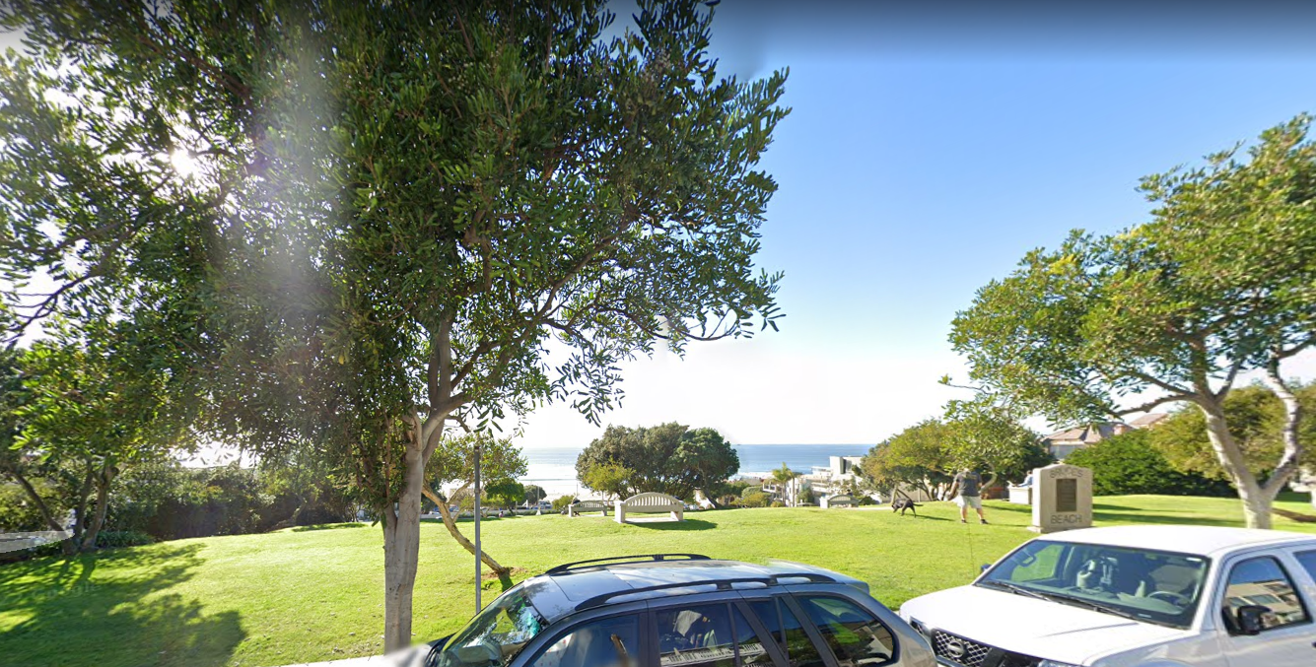
Bruce’s Beach Park as viewed from Highland Ave.

Application Requirements:
Please follow all application instructions and requirements in the Application Check List
Applications arriving past the deadline or incomplete applications will not be considered
No persons employed by, elected, or appointed in an official capacity by the City of Manhattan Beach or immediate family members thereof, shall be eligible for this project
All materials must arrive to submissions@manhattanbeach.gov, no later than 5:00 PM on March 31, 2023
Eligible applications must include:
- A professional resume/cv including contact information (name, address, phone, email, web address)
- A letter of interest outlining your desire to create this artwork, a description of and inspiration for the proposal, a narrative explaining your ability to collaborate with the City if selected for this project, and a brief description of projects of similar scope and complexity you successfully completed in the past
- A maintenance plan; this can be included in the letter of interest or may be a separate document. The maintenance plan must outline how frequently and utilizing what materials and techniques the artwork is to be maintained. It must also make provisions/recommendations for repairs, should the artwork sustain damage. Due to the projected longevity of this artwork, the maintenance/repair of the artwork or any of its components may not rely solely on the artist and must be able to be performed by another party should the artist not be able or available to complete the work.
- A color rendering of the proposed artwork (two to three views, including details if needed) with a brief description of the depicted artwork including the inspiration, materials, size, weight, imagery/iconography, and relationship to the site and history of Bruce’s Beach
- At least six images of similar work the artist successfully completed in the past, focusing on artworks of similar size, material, use, and scope to what is proposed; images must be accompanied by an annotated image list that clearly indicates the title, dimensions, materials, date of completion, location, budget, and commissioning/purchasing entity if applicable for each artwork shown
- Three references for similar commissioned work with current contact information
- Completed Budget Worksheet outlining all costs associated with the artwork
Selection Information:
The final selected artist will be contracted through the City to develop and finalize the art concept in close collaboration with the City, this may include several rounds of revisions to the proposed design that the parties shall mutually agree upon. Please review the attached sample Artist Agreement. The target installation deadline for this artwork is November 2024. The artist will have approximately 12 months after the final approval of artwork by City Council to complete the artwork (including all administrative/permitting/contract details, fabrication/delivery/installation etc.) to unveil the artwork by the above deadline.
Selection Process
The Art in Public Places Committee (APPC) will select 12 applicants from the eligible pool of applicants and make recommendations to the Cultural Arts Commission (CAC). The CAC will narrow those 12 applicants to eight and recommend to City Council (CC), who will then select five semi-finalists.
The City will organize a virtual Town Hall meeting with the five semi-finalists, led by a selected member of the APPC. Public comments, participation, and questions for the artists will be facilitated by staff and the selected APPC member to foster understanding of the proposed submissions and flesh out any ideas or concerns. The semi-finalists will each prepare a maquette of their proposal, incorporating feedback received from the Town Hall meeting, and including samples of materials and finishes as well as any changes that may result from collaboration with the City. A stipend of $1,000 will be paid to each semi-finalist for the production and shipping/delivery of the maquette. All semi-finalists are required to visit the location of the artwork and meet with City staff prior to submitting the final maquette. Applicants traveling to the site from more than 100 miles away may be reimbursed for travel, lodging, and per diem expenses not to exceed $2,000. An itemized invoice and all receipts must be provided for reimbursement. All semi-finalists will enter into a contractual agreement with the City of Manhattan Beach which will outline the terms of payment and reimbursement as well as timelines and other obligations as they pertain to this stage of the selection process. The City of Manhattan Beach will retain possession and ownership of all maquettes and other materials presented by the semi-finalists for review.
The maquettes will be presented by each artist to the APPC and the CAC, who will make recommendations on the finalist to City Council. The City Council will review all proposals and recommendations and will award project to the finalist.
The finalist will then work with City to finalize the design of the selected artwork. The selected artist will enter into an agreement substantially in the form attached (Sample Artist Agreement).
Additional Resources
  - Application Check List
  - Budget Worksheet
  - Sample Artist Agreement
  - www.manhattanbeach.gov
  - Bruce’s Beach History Report
  - Bruce’s Beach Task Force – https://www.manhattanbeach.gov/government/city-manager/bruce-s-beach-task-force
  - California Building Code ADA Requirements – CHAPTER 11B ACCESSIBILITY TO PUBLIC BUILDINGS, PUBLIC ACCOMMODATIONS, COMMERCIAL BUILDINGS AND PUBLIC HOUSING, 2022 California Building Code, Title 24, Part 2 (Volumes 1 & 2) | ICC Digital Codes (iccsafe.org)
Contact Information
For questions regarding this project, please contact Cultural Arts Manager, Eilen R Stewart at submissions@manhattanbeach.gov
Application Check List
This Check List is intended to streamline the application process and avoid lost, misplaced, or incomplete application materials. Please follow the list below and check off completed items as you go. For questions regarding this project, please contact Eilen R Stewart at submissions@manhattanbeach.gov
Before you begin:
- Compile all materials into one email or document prior to sending (multiple emails with varying information can be difficult to track, if multiple emails must be sent, make sure to use the same email account for all communication)
- Use email subject line – BB Application Your Name
  - If anticipating sending multiple emails, include: Email 1 of 2, Email 2 of 2 as needed
- Label all files with your name (First Last) and “BB Application”
- All images must be in PDF format, each image may not exceed 1MB in size
- For rendering/proposal images, label each one with a number such as: View 1, Detail 1 etc.
- For portfolio/previous project images, label each image with title of artwork pictured corresponding to an image list
- Email all materials to submissions@manhattanbeach.gov no later than 5:00 PM on March 31, 2023
Did you include:
 Resume/CV
- Make sure to include your contact information including – name, email address, phone number, address, website, or social media
 Letter of Interest and Maintenance Plan
- Why are you a good fit for this project
- Description of your proposal (physical and thematic)
- Description of projects of similar scope you have completed
- Are you willing/able to collaborate with the City to refine the proposal for final artwork if selected
- Maintenance Plan
  - make sure to list how the artwork is to be cared for, how frequently, with what materials/supplies
  - what types of damage is the artwork likely to sustain and how can it be repaired
  - the maintenance/repair of the artwork must not depend on the proposing artist as the piece may outlive the professional career thereof
  - the maintenance plan may be part of the letter of interest or a separate document
 Color Rendering of Proposal
- Two to three views of proposed artwork, include detail views if needed
- Description of proposal including inspiration, didactic/thematic information, materials, size, and relationship to Bruce’s Beach History – this description may be included as part of the Letter of Interest or as a separate document
 Portfolio/Previous Work
- At least 6 images of previous artworks of similar scope
 Annotated Image List for Portfolio
- For each image in the portfolio/previous work, please include a list with the following information: title of artwork, dimensions, materials, date of completion, location, budget, commissioning/purchasing entity
 Budget Worksheet
- The budget for this project is up to $350,000 and is all inclusive
- A project with a lower budget may be proposed and accepted, however once awarded, the budget for the selected project may not be adjusted or increased other than in very rare cases and upon written agreement by both parties (City and Artist)
 References
- Please provide contact information only (email and phone)
- Do not include letters of reference
- Provided references should be able to speak to the applicant’s ability to complete this or other projects of similar scope; ideally these should be parties that have worked directly with the applicant on similar projects

Budget Worksheet
To be filled out by each applicant and submitted with application

Item | Cost
Artist fee (not to exceed 25% of budget)
Materials
Fabrication
Installation
Transportation/delivery
Engineering cost/study
Permits/fees
Geological/site survey
Foundation/concrete work
Contingency (not to exceed 10% of budget)
Total budget for artwork:

Note: Be sure to include any additional fees not listed in this chart

